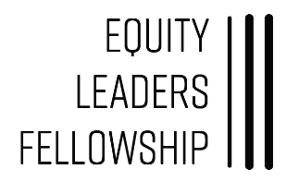
Equity Leaders Fellowship (ELF) Cohort 7: Class of 2021
Employer Support Form
The Equity Leaders Fellowship (ELF) program has a limited number of participants and is at no cost to the participant or the employer.
This Employer Support Form confirms that you support your employee to be part of the ELF program. You understand that your employee will be attending sessions beginning in September and may need to leave early from work. The sessions will consist of two day-long Saturday seminars for the first and last meeting, while sessions 2-7 will meet on Fridays of each month, October through April, as follows:
Session | Date | Day/Time | Topic
Session 1 | September 26, 2020 | Saturday, 9:30am-3:30pm | Leadership & the NH Context
Session 2 | October 17, 2020 | Friday, 4-8pm | Race & Self-Awareness
Session 3 | November 20, 2020 | Friday, 4-8pm | Board Dynamics
Session 4 | December 18, 2020 | Friday, 4-8pm | Inequality & Power
Session 5 | January 15, 2021 | Friday, 4-8pm | Communication
Session | February 19, 2021 | Friday, 4-8pm | Makeup for Snow Day
Session 6 | March 19, 2021 | Friday, 4-8pm | Change & Critical Thinking
Session 7 | April 16, 2021 | Friday, 4-8pm | Civic & Community Engagement
Session 8 | May 15, 2021 | Saturday, 9:30am-3:30pm | Reflection & Learning

I grant my support for our employee, ___________________________________________ to participate in the Equity Leaders
Fellowship (ELF) program.
Company/Organization Name: ____________________________________________________________________
Address: _____________________________________________________________________________________
Supervisor’s Name: _____________________________________________________________________________
Supervisor’s email and phone: ____________________________________________________________________
Supervisor’s Signature: _________________________________________ Date: _______________________
Employee Signature: ___________________________________________ Date: _______________________

